Home Learning – Week 4 2021 – Year 3
Online lessons – I will be providing a live English lesson TUESDAY-FRIDAY this week at 11.30, please try and join this by logging on to google classroom and clicking on the meet link
PE – Daily – Please use Joe Wicks PE videos which can be accessed from youtube.com – the Body Coach Tv.
READING –Don’t forget to read daily.

Monday
Phonics/spellings – see attached
Maths – White Rose maths home learning Spring Week 5 – Make Tally charts
https://whiterosemaths.com/homelearning/year-3/spring-week-5-statistics/
– watch the video and complete the worksheet attached.

English – Please take this time to complete the writing of your superhero story.

History – Watch the BBC bitesize video about Alfred the Great.
https://www.bbc.co.uk/bitesize/topics/zxsbcdm/articles/z9tdq6f
Task: Match the words with the pictures on the attached document and use these to produce a leaflet about Alfred the Great.

Tuesday
Phonics/spellings – see attached
Maths – White Rose maths home learning Spring Week 5 – Draw Pictograms 2,5, and 10
https://whiterosemaths.com/homelearning/year-3/spring-week-5-statistics/
– watch the video and complete the worksheet attached.

English – Online lesson

Science – Oak National Academy - https://classroom.thenational.academy/units/materials-de3f
Lesson 4 – Which materials float and sink?

Wednesday
Phonics/spellings – See attached

Maths – White Rose maths home learning Spring Week 5 – Interpret Pictograms 2,5 and 10
https://whiterosemaths.com/homelearning/year-3/spring-week-5-statistics/
– watch the video and complete the worksheet attached.

English-online lesson-

RE – Please complete the assessment task> This is a year 2 task as this is the RE year we are on, however could year 3 please include some sentences about why John the Baptist is a special person to them (the name of our school!) and why he was a special person to God and email it to me or upload it to the Google classroom. Watch the video to remind yourself of the story. https://www.youtube.com/watch?v=m1UfDgI4vto

Thursday
Phonics/spellings – see attached links.
Maths – No White Rose today. Please could you log on to IXL-Maths-Year 3 – Complete the following:
R.2 – Which tally chart is correct?
R.3 – Interpret Tally charts

English – online lesson –

Music – Oak National Academy – Rhythms, symbols and patterns – watch the video
https://classroom.thenational.academy/lessons/rhythm-symbols-and-patterns-6mw68t
French – Oak National Academy- Introducing and describing yourself in French
https://classroom.thenational.academy/lessons/introducing-and-describing-yourself-in-french-6hh62r

Friday
Phonics/spellings – see attached.
Maths – No white Rose Maths. Log on to IXL – Maths – Year 3 and complete the following:
R.9 Interpret Pictograms 1
R.10 Interpret Pictograms 2
R.11 Create Pictograms

English – online lesson.

PSHE – Me, You and us – Lesson 4 – Team Player – You will you’re your scrapbook, paper, pencil and colouring pencils. Watch video:
https://classroom.thenational.academy/lessons/team-player-6mrpcd

Art – Can you design and draw a Viking shield.
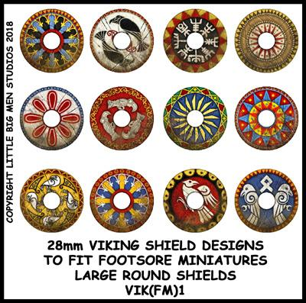

COMPLETED WORK

Please could all work completed be either emailed to me (dwaiters@st-johns-dartmouth.devon.sch.uk) or uploaded to the Google Classroom by clicking on classwork.

