Year B  Autumn 1 | Year B  Autumn 2
Topic The Romans | Topic Our Changing World
Enquiry Questions How did the arrival of the Romans change Britain?  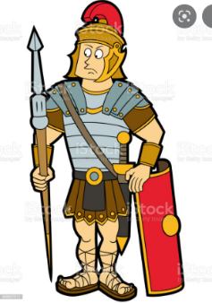 | Enquiry Questions  How can we live more sustainbly?  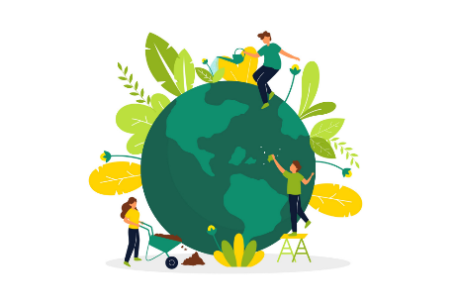
Virtues  Magnanimity – to undertake difficult tasks with courage and confidence | Virtues  Humility- to discover the truth about ourselves and take action for positive change.
Link with Catholic Social Teaching  Stewardship – How can we be stewards of our classroom, school, community and our world | Link with Catholic Social Teaching  Solidarity and the common good ● Rights and responsibilities
UN Sustainable Development Goals – Peace, Justice and Strong Institutions Goal 16  Reduced Inequalities Goal 10 | UN Sustainable Development Goals  How can we care for our Common Home?  Links with Laudato Si, Copp 26
Texts to support learning  How to be a Roman in 21 Easy Stages Juliet Kerrigan  Boudicca Claire Llewellyn, Laura Tolton | Texts to support learning  Blue Planet II by Leisa Stewart-Sharpe & Emily Dove
Visit to support learning – Steve Manning Roman Soldier and storyteller
Science – Electricity | Science- Light
History – Romans | Geography- How can we live more sustainably?
PSHCE- Healthy lifestyles | PHSCE- Keeping Safe
RE -Domestic Church Family  Ourselves Created in the image and likeness of God | RE- Hope and Mission
Music How does music bring us together? Y6 | Music- How does music bring us together?
Art 3D Structures – Use natural or recycled man-made materials to create sculpture | Art- Colour: Use colour to create an effect.  Pattern: Apply Roman geometric patterns to mosaics
 | DT – Frame structures
Computing - Design programmes including those controlling or simulating physical systems | Computing- Design programmes including those controlling or simulating physical systems
French Presenting Myself | French Presenting Myself
PE Football | PE Gymnastics

