Year B  Spring 1 | Year B  Spring 2
Topic  The British Empire 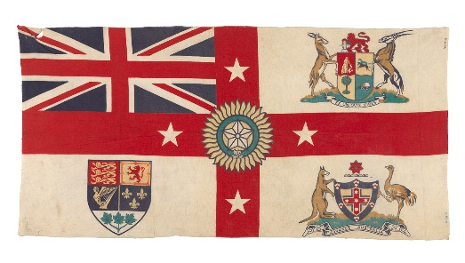 | Topic  How is India saving the Tiger?  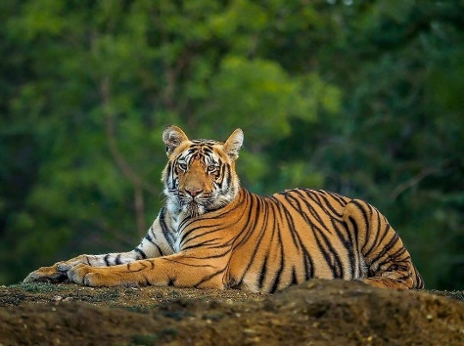
Enquiry Questions  Why did Britain once rule the largest empire the world has ever seen?  Why did Britain want an empire? Why has the British Empire all but disappeared? Was the British Empire a force for good or evil? | Enquiry Questions  How is India saving the Tiger?
Virtues  fortitude, temperance, and justice. | Virtues  fortitude, temperance, and justice.
Link with Catholic Social Teaching  Participation | Link with Catholic Social Teaching  Common Good
UN Sustainable Development Goals  9. Industry, innovation, infrastructure | UN Sustainable Development Goals  16. Peace, justice and strong institutions
Texts to support learning  Young Commonwealth website at www.youngcommonwealth.org/our-story/.  The History of Britain - Usborne | Texts to support learning  https://kids.britannica.com/kids/article/tiger/353858
Trips/visitors/events to enhance learning  Animal Encounters | Trips/visitors/events to enhance learning  Paignton Zoo or guest speaker
Science – Evolution and Adaptation | Science- Living things in their habitat
History – The British Empire | Geography- How is India saving the Tiger?
PSHCE- | PHSCE-
RE – Gift/ Community | RE- Giving and Receiving/Self discipline
Music- How Does Music Improve Our World?  Gaining confidence through performance – Disco Fever | Music-
Art – Digital Art | Art-
DT - | DT – Frames and structures – photo frames
Computing - | Computing- Design write and debug
French - | French
PE – ball games | PE – team games/ athletics

