Year B Autumn 1 | Year B Autumn 2
Changing Times | 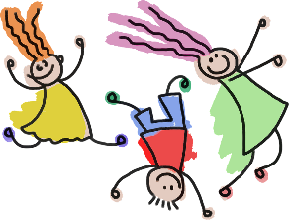  All about me!
Enquiry Questions  How does the weather affect our lives? | Enquiry Questions  How have we changed? What makes me special?
Virtues  Health (Prudence) | Virtues  Health (Prudence)
Link with Catholic Social Teaching  Family and community; Rights and Responsibilities, | Link with Catholic Social Teaching  Dignity of the Human Person; Family and Community, Stewardship
UN Sustainable Development Goals  Goal 2 Zero Hunger  Goal 3 Good Health and wellbeing | UN Sustainable Development Goals  Goal 3 Good Health and wellbeing
Texts to support learning  Knock Knock Who’s There? Percy the Park Keeper. Rosie’s Walk | Texts to support learning  Whatever Next – Jill Murphy  Can’t you sleep Little Bear? – Martin Waddell  When I Was Little Like You by Jill Paton Walsh and Stephen Lambert. The Growing Story by Helen Oxenbury and Once There Were Giants by Martin Waddell and Penny Dale
Trips/Visits | Trips/Visits  Local area walk
Science – Seasonal changes | Science – Humans – Exercise, nutrition, hygiene.
Geography - identify seasonal weather patterns in the UK.  How does the weather affect our lives? | History – How have we changed?
PSHCE – Health and well-being.  Me, My Body and my Health | PSHCE – Health and well-being.  Emotional wellbeing, Life cycles
RE - Families, Judaism | RE - Belonging, Baptism, Waiting,
Music – Adding rhythm and pitch | Music - Singing
Art – Drawing | Art - Painting
DT | DT – Mechanisms sliders and levers
Computing | Computing - Create and debug simple programmes
PE – Games – multi skills | PE – Gymnastics

Year B Spring 1 | Year B Spring 2
Animal Wood | 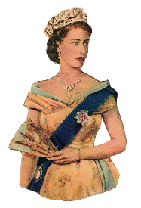  The Royal Family
Enquiry Questions  Why are woodland habitats important? | Enquiry Questions  Why do we have celebrations and ceremonies?
Virtues  Play | Virtues  Play Honesty
Link with Catholic Social Teaching  Rights and responsibilities, Care for Creation, Stewardship | Link with Catholic Social Teaching  Solidarity and the Common Good. The Dignity of Work
UN Sustainable Development Goals  Goal 15 Life on land | UN Sustainable Development Goals  Goal 16 Peace Justice and Strong Institutions
Texts to support learning  The Gruffalo – Julia Donaldson  The Gruffalo’s child – Julia Donaldson  The Tiger Who Came to Tea  Oi Frog – Kes Gray  The Woods | Texts to support learning  A Crown for Lion. Katie in London.  The Queen’s Hat  Rex and the Crown Jewels Robbery,
Trips/Visits  Local area walk | Trips/Visits
Science – Plants - trees | Science – Animals including humans
Geography – How are the Gruffalo’s woods different or the same to our local woods and the Rainforest? | History - What happens at a coronation?
PSHCE – Living in the wider world | PSHCE – Relationships
RE – Special people. Islam | RE - Meals, Change, Lent
Music - | Music - Exploring tempo and dynamics
Art – Printing | Art - Textiles
DT - Structures | DT –
Computing | Computing - Use logical reasoning to predict the behaviour of simple programmes
PE - Dance | PE – Multi skills

Year B Summer 1 | Year B Summer 2
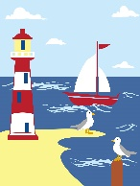  Seaside | 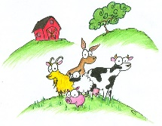  On the Farm
Enquiry Questions  Why do we love being beside the seaside? | Enquiry Questions  How can we care for our world?
Virtues  Honesty | Virtues  Play Honesty
Link with Catholic Social Teaching  Rights and responsibilities, Care for Creation, Stewardship | Link with Catholic Social Teaching  Rights and responsibilities, Care for Creation, Stewardship
UN Sustainable Development Goals  Goal 15 Life on land | UN Sustainable Development Goals  Goal 15 Life on Land
Texts to support learning  Katie Morag stories  Rainbow Fish  Mrs Armitage and the Big Wave - Quentin Blake | Texts to support learning  What the Ladybird Heard.  The Little Red Hen
Trips/Visits  Beach trip/Aquarium | Trips/Visits  Pennywell Farm
Science – Plants | Science – Materials
Geography – How is the island of Coll linked to our local area? | History – Did milk always come in a carton?
PSHCE – Relationships | PSHCE – Keeping Safe
RE – Pentecost – Good news! | RE - Friends, Our World
Music - Singing songs. | Music - Exploring timbre and tempo
Art – 3D work | Art – Painting and collage
DT - | DT – Food
Computing Algorithms – instructions: implementing and executing | Computing -
PE – Athletics | PE –Rounders

