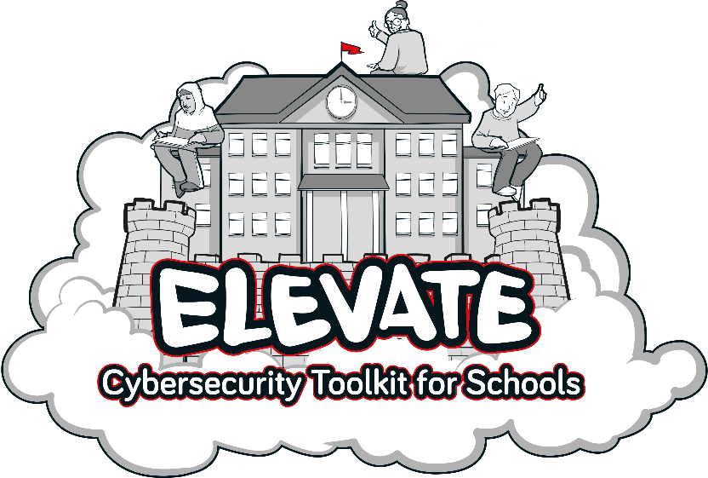

Introduction
A cybersecurity incident can have a major impact on any organisation for extended periods of time. For a school, this can range from minor reputational damage and the cost of restoring systems from existing backups, to major incidents such as losing student work or access to learning platforms and safeguarding systems, which could lead to data-protection fines or even failing an inspection.
This Cybersecurity Policy outlines St John’s guidelines and security provisions which are there to protect our systems, services and data in the event of a cyberattack.

Scope of Policy
This policy applies to all St John’s staff, contractors, volunteers and anyone else granted permanent or temporary access to our systems and hardware. It also covers the physical and technical elements that are used to deliver IT services for the school.

Risk Management
St John’s will include cybersecurity risks on its organisational risk register, regularly reporting on the progress and management of these risks to Governors [XX] times a year.
[ LGfL provide a Risk Register Template which is available here ]

Physical Security
St John’s will ensure there is appropriate physical security and environmental controls protecting access to its IT Systems, including but not limited to air conditioning, lockable cabinets, and secure server/communications rooms.

Asset Management
To ensure that security controls to protect the data and systems are applied effectively, St John’s will maintain asset registers for, files/systems that hold confidential data, and all physical devices (servers, switches, desktops, laptops etc) that make up its IT services.

User Accounts
Users are responsible for the security of their own accounts. If at any time they believe their credentials may have been compromised, for example after a phishing scam, they must change their password and inform TME as soon as possible. Personal accounts should not be used for work purposes. St John’s will implement multi-factor authentication where it is practicable to do so.

Devices
To ensure the security of all St John’s issued devices and data, users are required to:
- Lock devices that are left unattended
- Update devices when prompted
- Report lost or stolen equipment as soon as possible to TME.
- Change all account passwords at once when a device is lost or stolen (and report immediately to St John’s
- Report a suspected threat or security weakness in St John’s systems to TME.
Devices will be configured with the following security controls as a minimum:
- Password protection
- Full disk encryption
- Client firewalls
- Anti-virus / malware software
- Automatic security updates
- Removal of unrequired and unsupported software
- Autorun disabled
- Minimal administrative accounts

Data Security
St John’s will take appropriate measures to reduce the likelihood of the loss of availability to, or the disclosure of, confidential data.
St John’s defines confidential data as:
- Personally identifiable information as defined by the ICO
- Special Category personal data as defined by the ICO
- Unpublished financial information
Critical data and systems will be backed up on a regular basis following the 3-2-1 backup methodology
- 3 versions of data
- 2 different types of media
- 1 copy offsite/offline

Sharing Files
St John’s recognises the security risks associated with sending and receiving confidential data. To minimise the chances of a date breach users are required to:
- Consider if an email could be a phishing email or that a colleague’s account could be ‘hacked’. If something does not feel right check with the sender by another method, particularly in relation to financial transactions, attachments, or links to websites
- Wherever possible, keeping St John’s files on school systems
- Not sending school files to personal accounts
- Verifying the recipient of data prior to sending
- Using file encryption where possible, sending passwords/keys via alternative communication channels
- Alerting [IT Support/DPO] to any breaches, malicious activity or suspected scams

Training
St John’s recognises that it is not possible to maintain a high level of Cybersecurity without appropriate staff training. It will integrate regular Cybersecurity training into Inset days, provide more specialist training to staff responsible for maintaining IT systems and promote a “No Blame” culture towards individuals who may fall victim to sophisticated scams.

System Security
TME will build security principles into the design of IT services for St John’s Security patching – network hardware, operating systems and software
- Pro-actively plan for the replacement of network hardware, operating systems and software before vendors stop providing security support for them
- Actively manage anti-virus systems
- Actively manage and test backups
- Regularly review and update security controls that are available with existing systems
- Segregate wireless networks used for visitors’ & staff personal devices from school systems
- Review the security risk of new systems or projects

Major Incident Response Plan
St John’s will develop, maintain, and regularly test a Cybersecurity Major Incident Response Plan. This will include identifying or carrying out:
- Key decision-makers
- Key system impact assessments and restoration priorities (i.e. which backups needs to be restored first for the school to become operational again)
- Emergency plans for the school to function without access to systems or data
- Alternative methods of communication, including copies of contact details
- Emergency budgets and who can access them / how
- Key agencies for support (e.g. IT support company)

Maintaining Security
St John’s understands that the financial cost of recovering from a Major Cybersecurity Incident can far outweigh the ongoing investment in maintaining secure IT systems. St John’s will budget appropriately to keep cyber related risk to a minimum.

 | Headteacher / Principal | Liz Hamilton
 | Chair of Governors | Laura Upton
 | Network manager / other technical support | TME
 | Date this policy was reviewed and by whom | Sept 2023
 | Date of next review and by whom | Sept 2024

